ROAD MAINTENANCE MANAGEMENT

# CHAPTER FOUR

# RESULTS

## Membership By Profession

Respondents are made up of civil engineers, materials engineers and quantity surveyors from Ghana and Liberia. The below shows that 108(65%) of the of them are Ghanaian while the remaining 59(35%) are from Liberia. There 113(68%) civil engineers, 22(13%) material engineers and 32(19%) quantity surveyors. For Ghanaian respondents, 82(49%) of them are from the Ghana Institute of Engineers and 26(16%) from the Ghana Institute of Surveyors. On the side of the Liberian respondents, 50(30%) of them are from the Engineering Society of Liberia (ESOL), 8(4.8%) from the Liberia society women Engineers (LSWE) and 1 person (0.6%) from the Society women engineers of Liberia (SWEL)

|  | Profession | | |  |
| --- | --- | --- | --- | --- |
| Characteristic | Civil Engineer1 | Materials Engineer1 | Quantity Surveyor1 | Total1 |
| **Professional Membership** |  |  |  |  |
| Engineering Society of Liberia | 37 (22%) | 10 (6.0%) | 3 (1.8%) | 50 (30%) |
| Ghana Institution of Engineers | 68 (41%) | 12 (7.2%) | 2 (1.2%) | 82 (49%) |
| Ghana Institution of Surveyors | 4 (2.4%) | 0 (0%) | 22 (13%) | 26 (16%) |
| Liberia society women Engineers | 3 (1.8%) | 0 (0%) | 5 (3.0%) | 8 (4.8%) |
| Society women engineers of Liberia | 1 (0.6%) | 0 (0%) | 0 (0%) | 1 (0.6%) |
| 1Frequency(%) | | | | |

## Years of Work Experience

Assessment was made on the years of work experience of the respondents. It is seen that the profession with highest working experience are the civil engineers, followed by the quantity surveyors and the materials engineers. The diagram shows that 17(15%) of civil engineers had at least 16 years of work experience as compared to materials engineers and quanity surveyors who had 1 and 9 years of experience respectively. Also 50(43%) of the civil engineers has at least one year of work experience which far outnumbers the material engineers and the quantity surveyors.

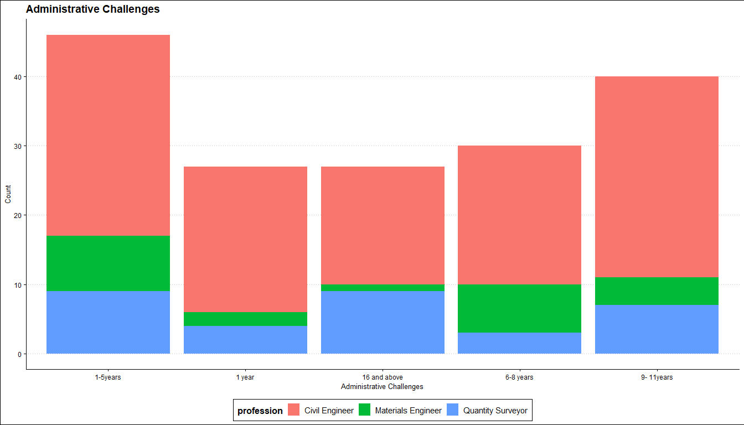

## Agencies That Organize maintenance training for the staff

The study indicates that there were periodic road maintenance training sessions organized by different agencies for the respondents in their various departments. These training session are organized either once a year, every 6 months or twice within year. According to the respondents, the road maintenance training session were organized the Ghana High Way Authority, Department of Feeder Roads, Department of Urban Roads, Beureua of Highway maintenance, GIZ, and Infrastructure implementation unit. The list agencies provided here is in order of frequency.

| Department | conduct maintenance training for its staff | | |  |
| --- | --- | --- | --- | --- |
| Characteristic | Every six months1 | Once a year1 | Twice a year1 | Total1 |
| **Organizing agency** |  |  |  |  |
| Beurea of Highway maintenance | 0 (0%) | 19 (12%) | 7 (4.3%) | 26 (16%) |
| Department of Feeder Roads | 6 (3.7%) | 28 (17%) | 6 (3.7%) | 40 (25%) |
| Department of Urban Roads | 7 (4.3%) | 19 (12%) | 8 (4.9%) | 34 (21%) |
| Ghana Highway Authority | 7 (4.3%) | 40 (25%) | 3 (1.8%) | 50 (31%) |
| GIZ | 1 (0.6%) | 3 (1.8%) | 3 (1.8%) | 7 (4.3%) |
| Infrastructure implementation unit | 0 (0%) | 4 (2.5%) | 2 (1.2%) | 6 (3.7%) |
| 1Frequency(%) | | | | |

## Key role of the Maintenance Department

Major of the respondent, i.e. 96 (57%) indicated that the key role of the maintenance department is the maintenance of all National, Inter-Regional, and Regional roads in the network. Thirty-two(32), representing 19% of them also stated that the maintenance department’s key role is to ensure expeditious collection of revenues from source. 23 (14%) opined that ensuring the adequacy of revenues for maintenance needs is the key role of the maintenance department, and the last but not the least group were eof the view that the road maintenance department’s key role is the efficient delivery of road infrastructure services.

| Characteristic | N = 1691 |
| --- | --- |
| **Key role of the Maintenance Department** |  |
| efficient delivery of road infrastructure services | 18 (11%) |
| ensuring expeditious collection of revenues from source | 32 (19%) |
| ensuring the adequacy of revenues for maintenance needs | 23 (14%) |
| maintenance of all National, Inter-Regional, and Regional roads in the network | 96 (57%) |
| 1Frequency(%) | | |

## Uncommon Road Defects

There are some road defects which are not commonly observed on the road. According the responses, bleeding, distresses, raveling, Longitudinal cracks and traverse cracks are some uncommon road defects. These are from 21 (13%), 6 (3.7%), 10 (6.2%), 10 (6.2%) and 8 (4.9%) respondents respectively. Other responses were a combination of two or more defects. For instance 45 (28%) of them stated Raveling and Bleeding as common, 25 (15%) stated Longitudinal cracks, Traverse cracks, Raveling and Bleeding as uncommon, 22 (14%) stated Traverse cracks, Raveling and Bleeding as uncommon and so on.

| Characteristic | N = 1621 |
| --- | --- |
| **Uncommon road defects** |  |
| Bleeding | 21 (13%) |
| Distresses | 6 (3.7%) |
| Longitudinal cracks | 10 (6.2%) |
| Longitudinal cracks;Traverse cracks;Raveling;Bleeding | 25 (15%) |
| Raveling | 10 (6.2%) |
| Raveling;Bleeding | 45 (28%) |
| Traverse cracks | 8 (4.9%) |
| Traverse cracks;Raveling | 15 (9.3%) |
| Traverse cracks;Raveling;Bleeding | 22 (14%) |
| 1Frequency(%) | |

## The activities before the actual field data work begins

Before any field data work begins, the respondents stated that certain activities are performed. These activities include but not limited to Selecting and training teams for collecting the data, Planning to allocate the requisite logistics for the exercise, Planning the entire calendar for data collection. Majority of the respondents 48 (29%) indicated that a combination of all these activities is performed before the actual field data work takes place.

| Characteristic | N = 1631 |
| --- | --- |
| **The activities before the actual field data work begins** |  |
| Planning the entire calendar for data collection. | 8 (4.9%) |
| Planning to allocate the requisite logistics for the exercise. | 16 (9.8%) |
| Planning to allocate the requisite logistics for the exercise.;Planning the entire calendar for data collection. | 10 (6.1%) |
| Selecting and training teams for collecting the data. | 28 (17%) |
| Selecting and training teams for collecting the data.;Planning the entire calendar for data collection. | 16 (9.8%) |
| Selecting and training teams for collecting the data.;Planning to allocate the requisite logistics for the exercise. | 37 (23%) |
| Selecting and training teams for collecting the data.;Planning to allocate the requisite logistics for the exercise.;Planning the entire calendar for data collection. | 48 (29%) |
| 1Frequency(%) | |

## How periodic road maintenance is organized

Periodically, road maintenance is organized in order to ensure longivity. The following are how the maintenance is done according the response of the study. 70 (42%) of the respondents stated that it is done by monitoring and checking the efficiency of road networks. 64 (38%) also stated that it is done by ensuring that a well-defined system of rules, standard operating procedures, and norms are in line with quality road networks.While the remaining 33 (20%) of them mentioned that road maintenance is organized by going by specific requirements of the Road Agency.

| Characteristic | N = 1671 |
| --- | --- |
| **Organization of periodic road maintenance** |  |
| ensuring that a well-defined system of rules, standard operating procedures, and norms are in line with quality road networks. | 64 (38%) |
| going by specific requirements of the Road Agency | 33 (20%) |
| monitoring and checking the efficiency of road networks | 70 (42%) |
| 1Frequency (%) | |

## Administrative challenges

In the administrative process of road maintenance management, the respondents indicated that some challenges are encountered. 80(47%) out of the 170 respondents stated that the major challenge is that Projects are under cost or over cost. Another challenge stated was if there is No time and Cost limits stated. Fifteen(15) others also made mention of that fact that if there is no specific project period stated, the process seem quite challenging. 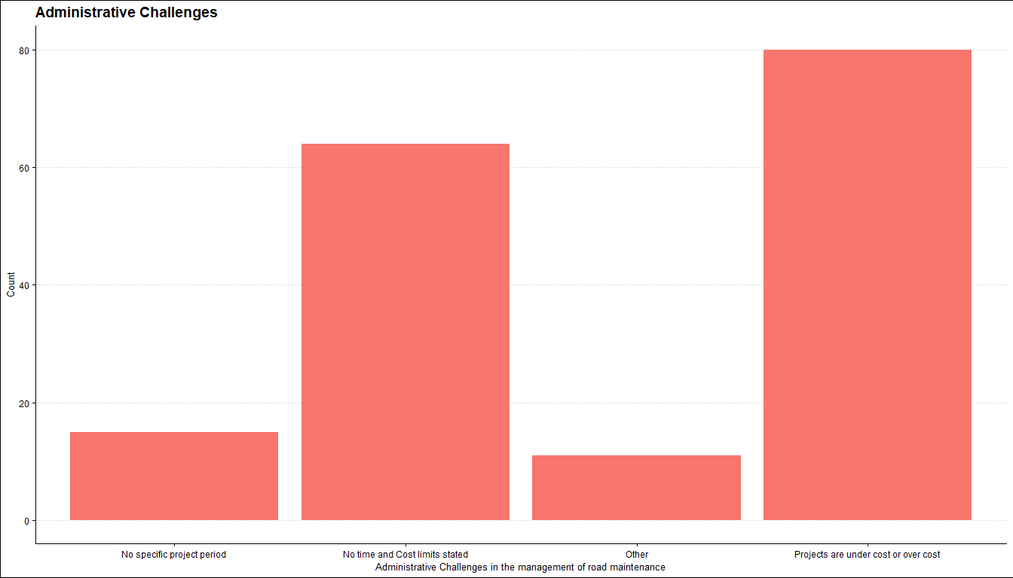

## Awarding Criteria

Certain criteria are looked out for in awarding road maintenance projects. The study reveals that least biller pricing is the major criteria, according to 75 (46%) of the respondents. 45 (27%) also opined that Company experience in similar work is greatly considered, while 13 (7.9%) were of the view that Designated contractors are looked out for.

| Characteristic | N = 1641 |
| --- | --- |
| **Criteria used in awarding road maintenance projects** |  |
| All the above | 31 (19%) |
| Company experience in similar work | 45 (27%) |
| Designated contractors | 13 (7.9%) |
| Least biller pricing | 75 (46%) |
| 1Frequency(%) | |

## Finance

The process of road maintenance management is funded by diverse source. In this study, most of the respondents indicated that their source of funding or their source of finance was from government allotment (96 (57%) respondents stated so). 8 (4.8%) of them also stated World Bank Aid as their major source of finance. 3 (1.8%) of them pointed their source of fund to Bank loans whles the rest of the respondents mentioned multiple sources as their source.

| Characteristic | N = 1681 |
| --- | --- |
| **Source for finance** |  |
| Bank Loan | 3 (1.8%) |
| Bank Loan;Government Allotment | 16 (9.5%) |
| Bank Loan;World Bank Aid;Government allotment;Bilateral Aid | 13 (7.7%) |
| Government Allotment | 96 (57%) |
| Government allotment;Bilateral Aid | 16 (9.5%) |
| World Bank Aid | 8 (4.8%) |
| World Bank Aid;Government Allotment | 16 (9.5%) |
| 1Frequency(%) | |

## Maintenance Work on Road Defects

The study inquired of how often certain road maintenance work is conducted on named road defects. The graph below show that major of the respondents indicated that most of the road maintenance works are done once in year (indicated in orange). The second highest group mentioned that these maintenance works are done after every six month, among others. Some of the names maintenance work include grass cutting, grading, erosion control, crack repairs, pothole patching etc. The graph gives details on this subject. The colors represent the frequency of road maintenance. For instance, 46% of the respondents mentioned replaceement of slabs and metal grating as an activity that takes place one time every year. 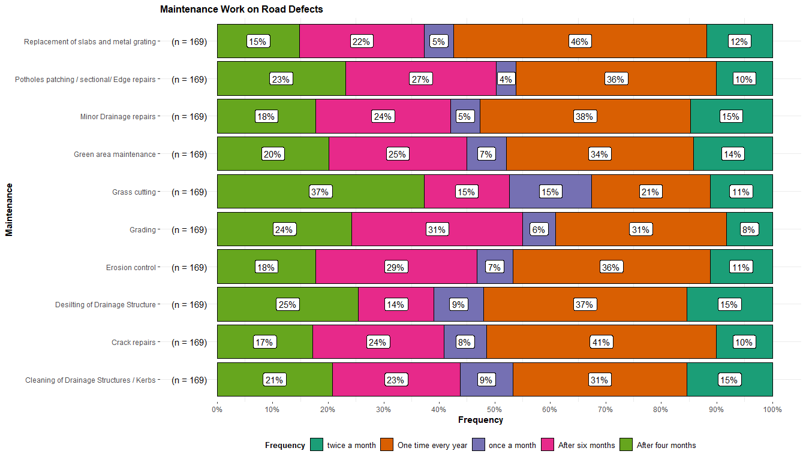

## Facilitators of a successful Implementation of Road Maintenance Procurement Contracts

For a successful implementation of road maintenance procurement contracts in an agency a number of issues affect it. The respondents were asked to rate how an outlined factors or issues affect(s) the subject at hand on the following scale; 1. Not at All 2. Very Low 3. Low 4. Medium 5. High. The degree of influence are represented with colors in the graph below while the vertical axis shows the factors. Not at all indicates that the factor has no influence on the successful Implementation of Road Maintenance Procurement Contracts. 